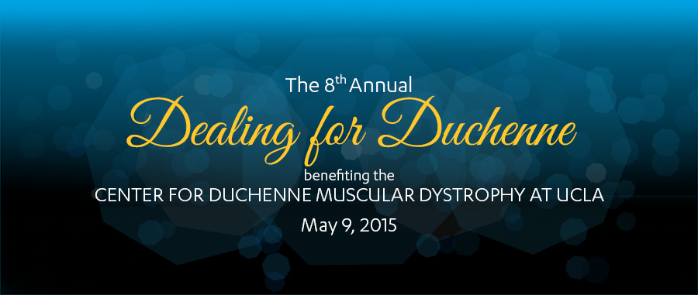
Please select your sponsorship level and complete the following information:
___ Royal Flush ♣ Presenting Sponsor ♣ $50,000 ($48,820 tax deductible)
Exclusive presenting sponsor naming rights for the event; Two VIP tables of 10 with premier seating in Presenting Sponsor section; Name and logo on step and repeat; VIP parking for 10 cars; Celebrity Poker Tournament buy-in for 20 people; Meet and greet with evening's entertainer; Option for on-stage check presentation; Full-page ad in program; Presenting Sponsorship acknowledgement by hosts; Name and logo on all printed materials and media outreach

___ Straight Flush ♠ Corporate Sponsor ♠ $25,000 ($24,410 tax deductible)
Exclusive naming rights for a premier area of choice: silent auction or poker room; 1 VIP table of 10 - premier seating in Corporate Sponsor section; Celebrity Poker Tournament buy-in for 10 people; VIP parking for 5 cars; Full-page ad in program; Corporate Sponsor acknowledgement by hosts; Name and logo on all printed materials and outreach

___ Four of a Kind ♥ Supporting Sponsor ♥ $12,000 ($11,410 tax deductible)
Company logo prominently displayed at event; 1VIP table of 10 - seating in Supporting Sponsor section; Celebrity Poker Tournament buy-in for 10 people; Full-page ad in program; Supporting Sponsor acknowledgement by hosts; Name and logo on all printed materials and media outreach

___ FuII House ♦ Table Sponsor ♦ $6,000 ($5,410 tax deductible)
Reserved table of 10; Celebrity Poker Tournament buy-in for 10 people; Half-page ad in program; Name and logo on all printed materials and media outreach

___ Three-of-a-Kind ♣ CDMD Friend ♣ $3,000 ($2,410 tax deductible)
Reserved table of 10

___ Individual Poker VIP ♠ $500 ($441 tax deductible)
Event ticket and Celebrity Poker Tournament buy-in for one person

___ Individual Ticket ♠ $200 ($141 tax deductible)
Event attendance only. Does not include poker buy-in.

TOTAL AMOUNT $_______________
Contact Name _______________________________________________________________________________________________________
Company _______________________________________________________________________________________________________
Address _______________________________________________________________________________________________________
Contact Phone ____________________________________ Email ___________________________________________________________

PAYMENT
□ Check □ Visa □ MasterCard □ Amex □ Discover
If paying by check, please make payable to: The UCLA Foundation - CDMD

Card# _______________________________________________________________________ Exp. Date _____________________
Name on Card _____________________________________________________________ CVV (3-4 digit code) _____________________
To charge by phone or for more information call: 310-779-7422 or 310-801-1180

PLEASE MAIL COMPLETED FORM TO:
Amy Martin - Center for Duchenne Muscular Dystrophy at UCLA
277 Biomedical Sciences Research Building • 615 Charles E. Young Dr. S. • Los Angeles • CA • 90095
Nonprofit Tax I.D. #95-2250801

