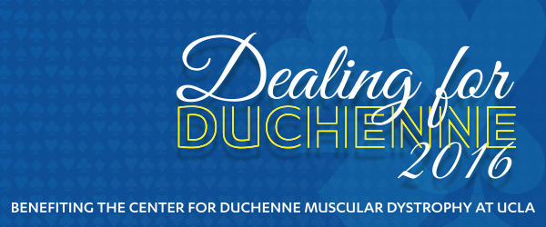

Thank you for your donation to Dealing for Duchenne 2016 silent and live auction. The proceeds from this event will help fund the Center for Duchenne Muscular Dystrophy at UCLA, the first comprehensive care and translational research center focused on Duchenne in the Western United States.

* Company :
* Contact :
* Street Address :
* City, State, Zip Code :
* Phone:
* Email:

Item(s) Donated:

Estimated Value:

* Description of Donation:

$ _

* Restrictions and Limitations (Ex : Expiration date, excluded dates, etc.):

For auction item pick up or information contact Amy Martin at: (310) 779-7422

Send gift certificates or packages to:

Amy Martin

3016 Bagley Ave L.A. CA 90034

*Confirmation receipts of your donation will be sent from CDMD at UCLA*

FAX COMPLETED FORM TO:

(818) 330-6818 OR email: ekli[nenberg@me.com](mailto:nenberg@me.com)

(Form Required for Listing in Auction Catalog)

The CDMD@ UCLA Foundation is a 501(c)(3) Non-Profit Organization - Fed.Tax ID #: 95-2250801