You are invited to The Muscle Cell Biology and Disease Annual Retreat
Hosted by The Center For Duchenne Muscular Dystrophy at UCLA

Grand Horizon Room

Covel Commons

Friday, November 21st, 2014

10:00AM – 6:00PM

Registration and coffee begin at 9:30AM

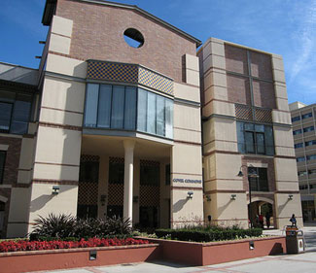

We hope that you will join us to learn about the latest research within the Center, Core Facilities and funding opportunities, and share your research.

Please RSVP

amymartin@ucla.edu

